

USER’S

MANUAL

OPD Management System

Sri Lanka Institute of information Technology
Group no :AF-WE-03

June 2017

Group Members

IT15135230 | A.A.B.S.Amarathunga
IT15110244 | J.H.N.S.Keerthirathna
IT15107206 | S.A.G.A.Suraweera
IT15117410 | S.P.U.K.Weerasinghe

USER'S MANUAL

TABLE OF CONTENTS

Page #

1.0 GENERAL INFORMATION
1.1 System Overview 1-3
1.2 Authorized Use Permission 1-3
2.0 SYSTEM SUMMARY
2.1 System Configuration 2.1
2.2 User Access Levels
3.0 USING THE SYSTEM (ONLINE) 3-1
3.1 System Function 3-1
3.1.1Out Nurse Department 3-1
3.2.1Out DoctorDepartment……………………………………………..…………………..3-1

GENERAL INFORMATION

1.1 System Overview
Technology has moved us into the world of automation and helped us in data keeping, making business reports, finance reports and recording various details in no time. OPD Management System is a small pocket to put in all the data and outpatient details without the tedious task of manual registration and searching it from the huge pile of existing files every time the patient visits. It is a complete software solution for Outpatients registration, treatments, billing and reporting with complete details of patient’s information.
It reduces your paper work and saves your time. As everything is squeezed in your system, you do not have to worry over maintaining various files and documenting everything.
At OPD management system we strive to bring technology to the doors of health industry through our customized series of various modules of Hospital Management software that comes handy in recording registration of patients, their history, staff records and billing. You can easily record outpatient’s registrations, billing details and history of patients. It enables you to access huge data just at the click of mouse through simple and attractive user interfaces.
All you have to do is enter the personal details of patient, consultation and hand over an automatically generated registration number to him. You can even fix appointments on the tool and see the schedule as well. OPDMS allows doctors to electronically prescribe the medicines or tests. The quick view facility lets the doctors to quickly view the historical prescriptions of each patient and give direction to further treatment.
OPD Module Includes Following Management System:
- Patients Management
- OPD Management
- Reports and Summaries
Key Features of OPDMS:
- Patient’s Complete Demographic Details
- Overall Patients Data Management
- OPD Prescriptions with Patients History
- Report Generation of Patients lab orders, prescriptions

Benefits of Using OPDMS:
- Paperless Record Keeping
- User Friendly System
- Easy Information Sharing
- Flexible Reporting System
- Complete Data Security with authorization
- A Centralized Patients record system
- Accessible with Doctors & other Staff Members
- Easy & Customizable Data Entry forms
- Helps to run entire Hospital’s functions smoothly

1.2 Authorized Use Permission

Any unauthorized usage of the system and making unauthorized copies of data, software, reports, and documents is not applicable.

2.0 SYSTEM SUMMARY

SYSTEM SUMMARY

It is a complete software solution for Outpatients registration, treatments, and reporting with complete details of patient’s information.

2.1 System Configuration

A printer is used to print the patient’s patient card.

2.2 User Access Levels

The access control of the system is maintained by necessary usernames and passwords. Doctors and nurses have separate login s to the system

3.0 USING THE SYSTEM (ONLINE)

USING the SYSTEM (ONline)

3.1.1 Out Patient Department (OPD)-Nurse view

1. Register new patient

This interface is for the first time registration of the patient with the system. These are

Some basic details which the patient should provide for the hospital for future necessities.

- Fields

Patient personal details => title, full name, other name, date of birth, gender, civil status

Patient identity details =>NIC, Blood group

Patient contact details =>address, phone, Guardian, Guardian Tell

Fields need to be filled
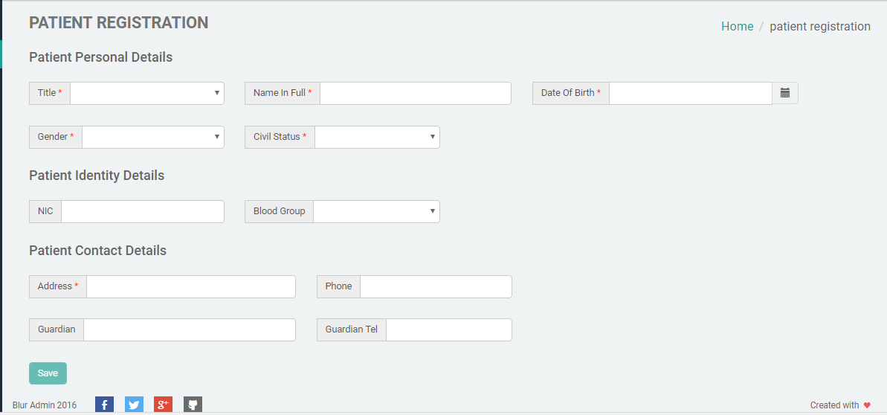

2. Search patient

This page provides facilities to search patients who have registered before.

• Fields

HIN, First name, NIC, telephone, date of birth, address

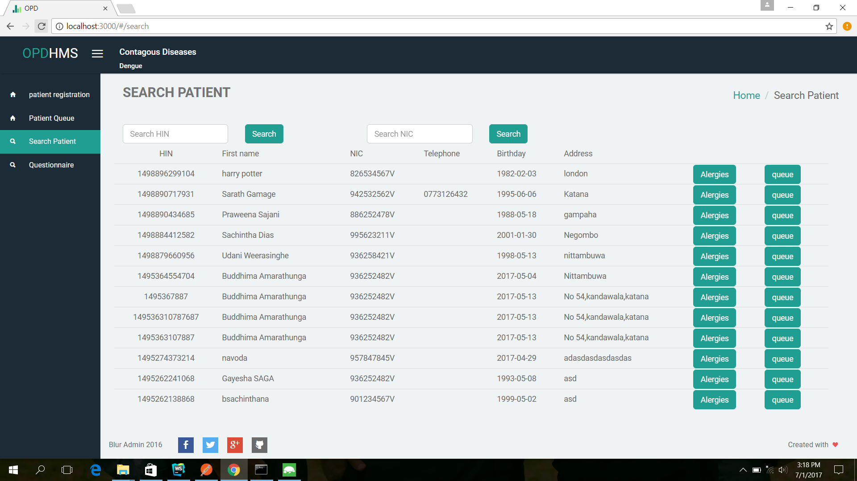

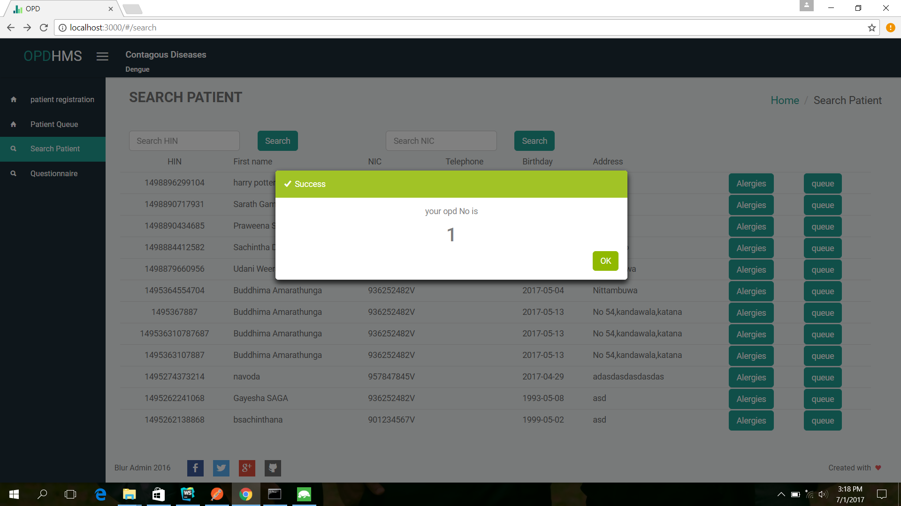
After searching if the patient can be found, he can be directed for the queue. He will be received an OPD number as bellow.

3. Add to queue

This interface gives the patient details.

Available doctor details and the number of patients in the queue for that particular
Doctor.

Left navigation bar:

Main menu =>patient overview

3.1.2 Out Patient Department (Doctor View)
1. OPD patients

This interface of OPD patients. Doctor can view his patient's details and click on a patients name to go to patient's profile.
• Fields
HIN, name, visit date, complaints, details

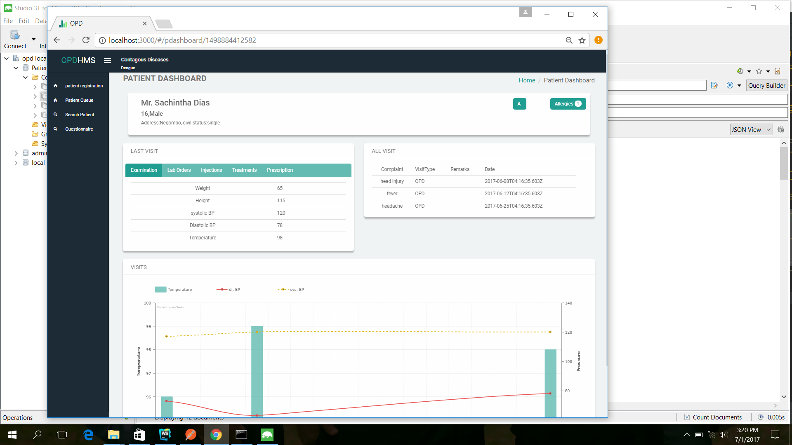

2. Questionnaires
- Add Questionnaires

Fields
Question name, relate to, remarks
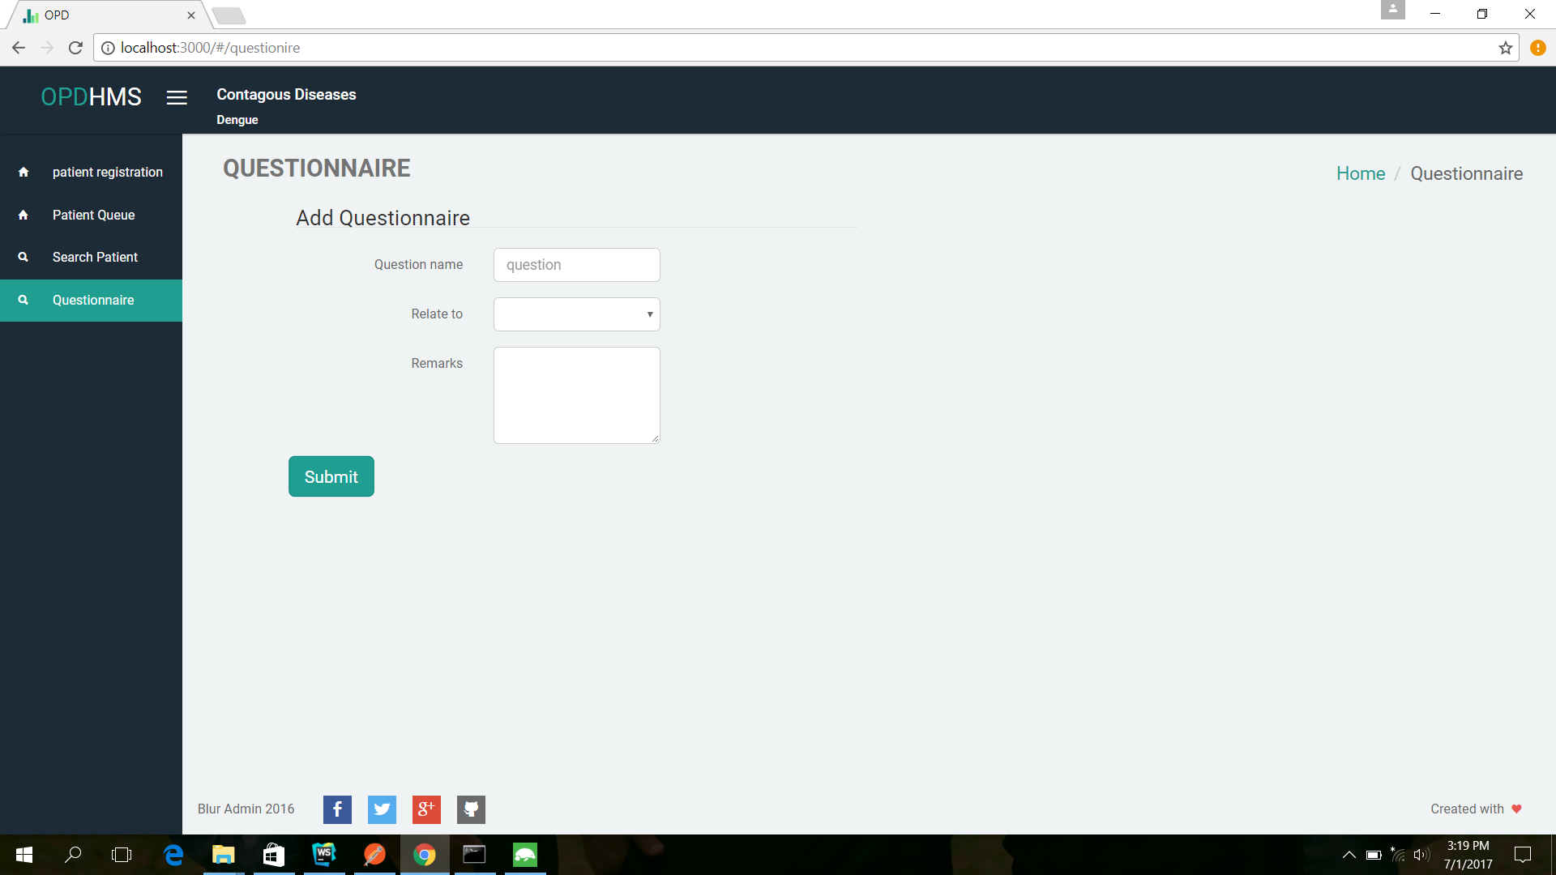
Add questions to the Questionnaire

Fields
Name, Answer type

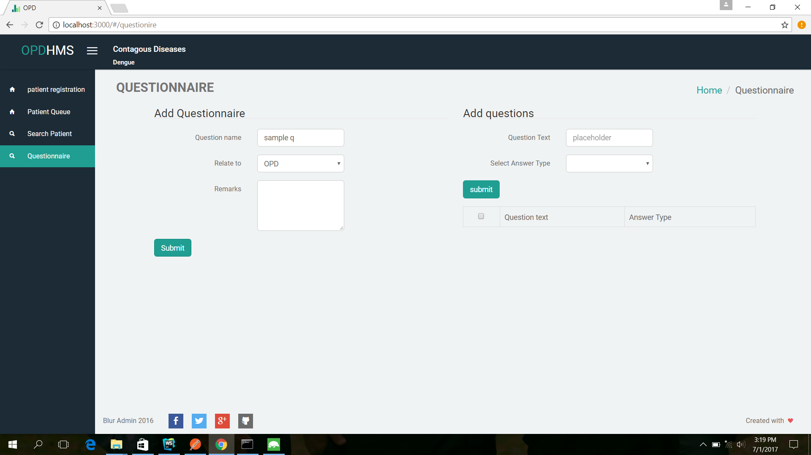

3. Patient profile

This is the patient profile interface. Doctor can view the patient history at a glance.
Doctor can view the previous visits, allergies, examinations, stationeries, lab orders, notes, commotion, and attachments. Therefore, that doctor can have a clear understanding of a patient before prescribing the drugs. Furthermore, doctor can add new allergies, notes, commotions, files to the respective patients.

• Fields
Patient details
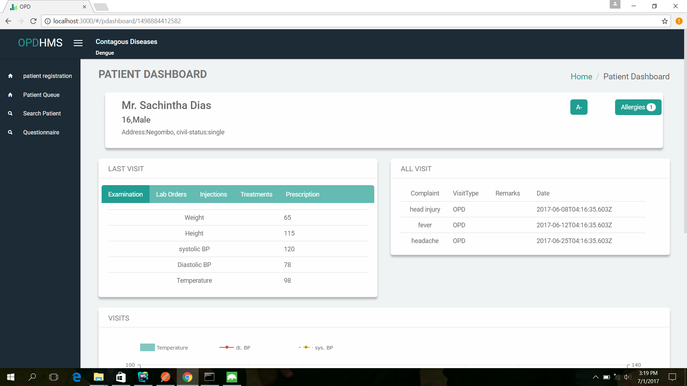
Name, Age, Address, gender, date of birth, phone, address, blood group, BMI and All visits he have received.

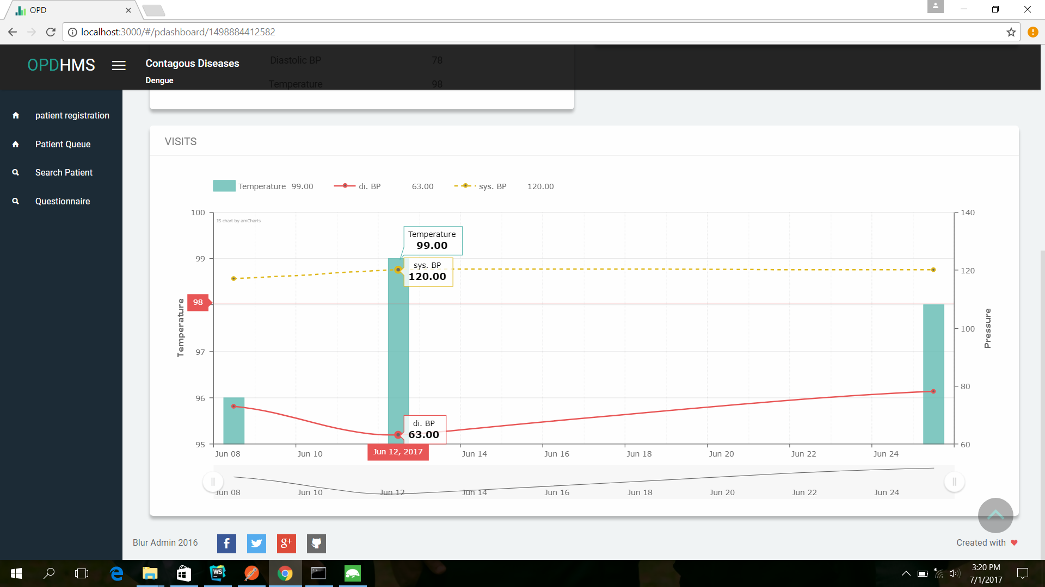
4. Patient Queue
To create a visit to a doctor, go to the patient Queue in left navigation bar .then click create visit button
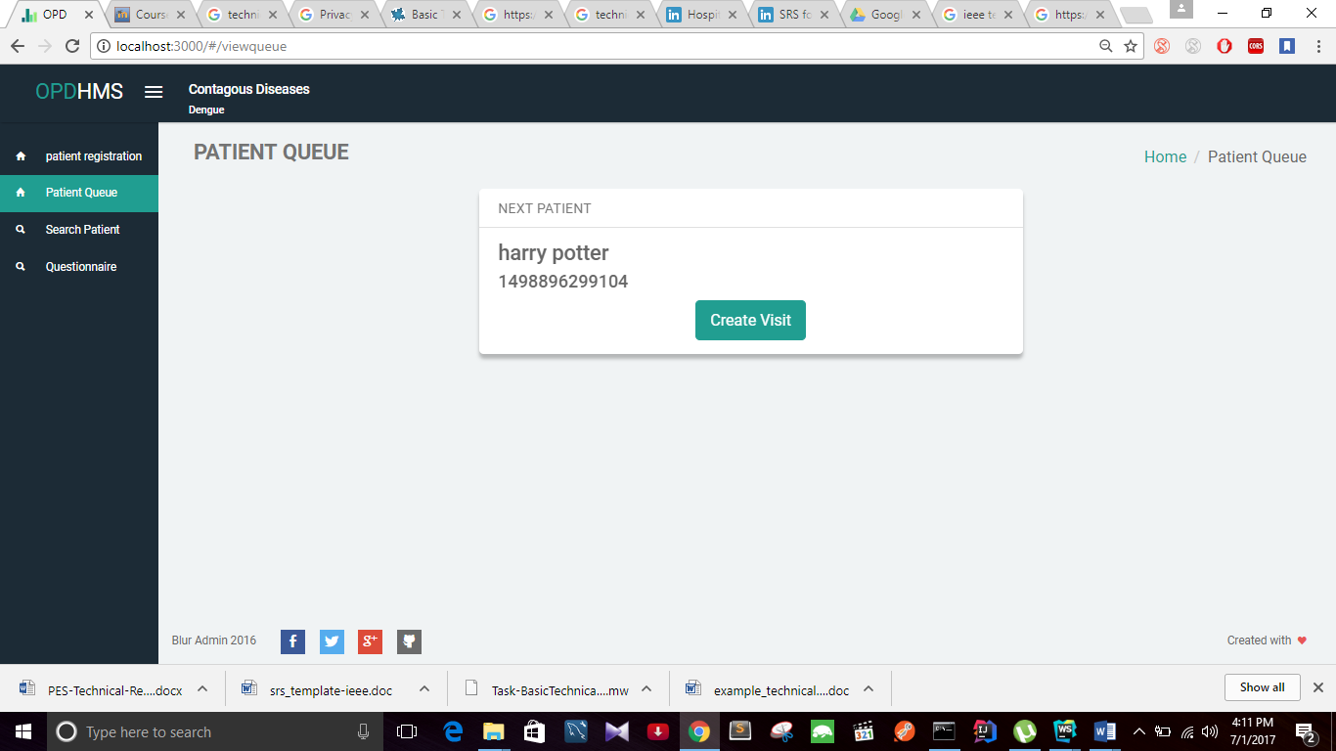

5. Create visits.

In this interface doctor need to create a visit tab for create a visit for the patients. After pressing create a visit tab, it is generating this interface. Doctor needs to enter the following details. By pressing the “Create” button, it is creating the visit.

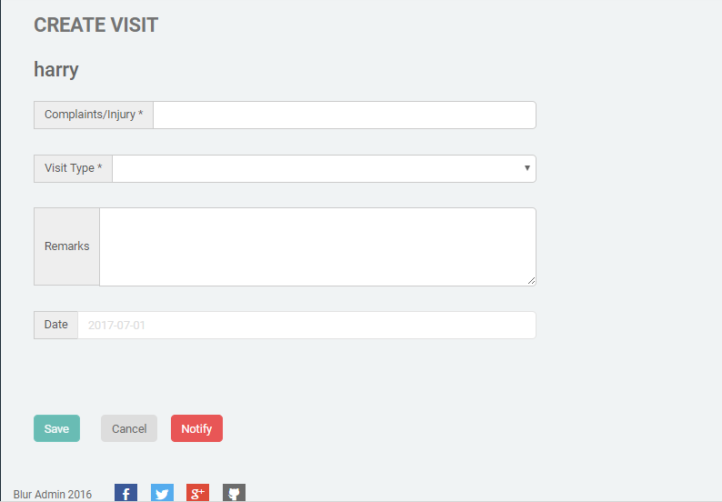

6. Create prescription.
Doctors can select drugs, add drug frequency and period to issue the drug list as a report.

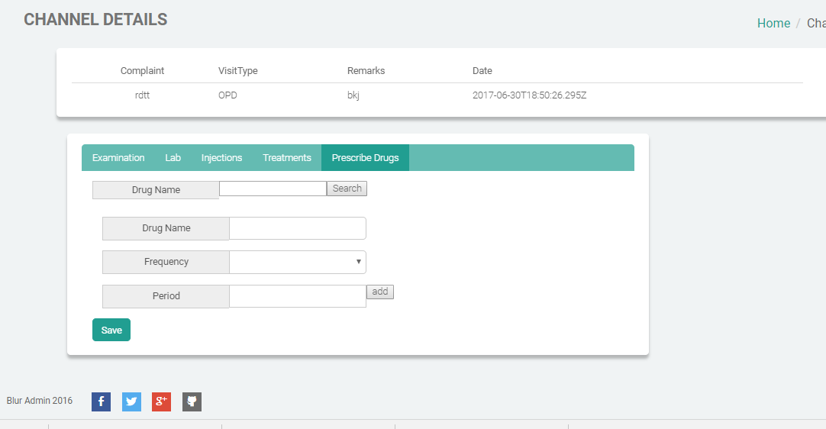

7. Lab Orders
Doctors can add lab orders according to their patient visits. Examinations, treatments, injections can also be added like this.
